**Question:**

Given that we get the following 4x4 confusion matrix after we run a multi-class classifier:

|  |  |  |  |  |  |
| --- | --- | --- | --- | --- | --- |
|  |  | ***System Output*** | | | |
|  |  | **Class1** | **Class2** | **Class3** | **Class4** |
| ***Gold Labels*** | **Class1** | 5 | 2 | 1 | 2 |
| **Class2** | 1 | 7 | 1 | 1 |
| **Class3** | 0 | 2 | 8 | 0 |
| **Class4** | 1 | 1 | 2 | 6 |

**Answer the following questions:**

1. Mark the cells *true positive* (Tp), *true negative* (Tn), *false positive* (Fp), *false negative* (Fn) w.r.t. Class2.

|  |  |  |  |  |  |
| --- | --- | --- | --- | --- | --- |
|  |  | ***System Output*** | | | |
|  |  | **Class1** | **Class2** | **Class3** | **Class4** |
| ***Gold Labels*** | **Class1** | TN | FP | TN | TN |
| **Class2** | FN | TP | FN | FN |
| **Class3** | TN | FP | TN | TN |
| **Class4** | TN | FP | TN | TN |

1. Mark the cells *true positive* (Tp), *true negative* (Tn), *false positive* (Fp), *false negative* (Fn) w.r.t. Class4.

|  |  |  |  |  |  |
| --- | --- | --- | --- | --- | --- |
|  |  | ***System Output*** | | | |
|  |  | **Class1** | **Class2** | **Class3** | **Class4** |
| ***Gold Labels*** | **Class1** | TN | TN | TN | FP |
| **Class2** | TN | TN | TN | FP |
| **Class3** | TN | TN | TN | FP |
| **Class4** | FN | FN | FN | TP |

1. Calculate Precision, Recall and F-1 for the classifier using both micro-averaging and macro-averaging. Show you complete work with all intermediate matrices.

|  |  |  |
| --- | --- | --- |
| **CLASS 1** | True **Class 1** | True **Not** |
| System **Class 1** | 5 | 2 |
| System **Not** | 5 | 28 |

|  |  |  |
| --- | --- | --- |
| **CLASS 2** | True **Class 2** | True **Not** |
| System **Class 2** | 7 | 5 |
| System **Not** | 3 | 25 |

|  |  |  |
| --- | --- | --- |
| **CLASS 3** | True **Class 3** | True **Not** |
| System **Class 3** | 8 | 4 |
| System **Not** | 2 | 26 |

|  |  |  |
| --- | --- | --- |
| **CLASS 4** | True **Class 4** | True **Not** |
| System **Class 4** | 6 | 3 |
| System **Not** | 4 | 27 |

**Macro Precision: (**5**/7 + 7/**12 + 8/12 + 6/9)/4

**= 0.658**

**Macro Recall: (**5**/**10 **+ 7/**10 + 8/10 + 6/10)/4

**= 0.650**

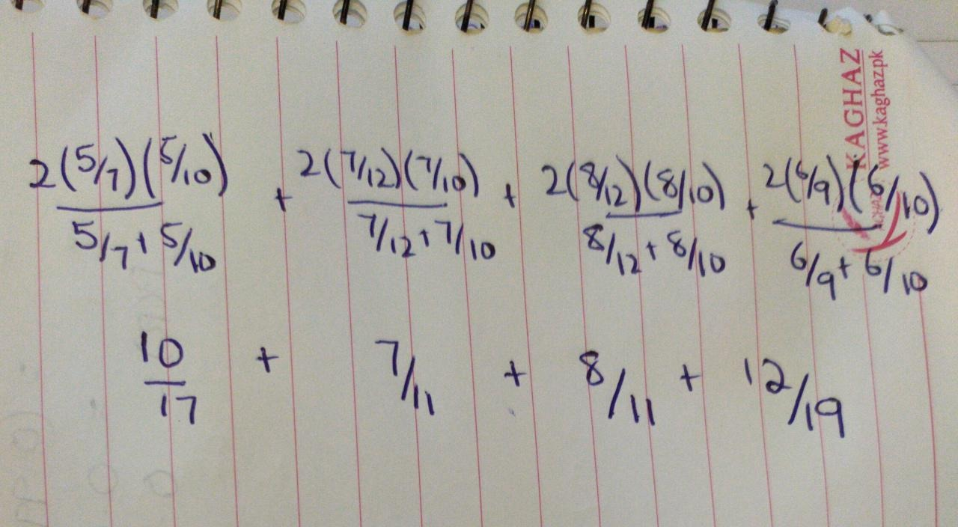

**Macro F1-Score** (10/17**+ 7/**11 + 8/11 + 12/19)/4

**= 0.646**

|  |  |  |
| --- | --- | --- |
| **POOLED** | True **Yes** | True **No** |
| System **Yes** | 26 | 14 |
| System **No** | 14 | 106 |

**Micro Precision:** (26/26+14) = **0.650**

**Micro Recall:** (26/26+14) = **0.650**

**Micro F1-Score:** 2(26/40) (26/40)/ ((26/40) + (26/40)) = **0.650**